1. **Perform sharpening of image using Laplacian Mask with negative centre coefficient.**

**Aim:**

To perform sharpening of image using Laplacian Mask with negative centre coefficient using python.

**Code:**

import cv2

import numpy as np

img=cv2.imread("C:\\Users\\prith\\Documents\\CV\\cvimage.jpg")

gray=cv2.cvtColor(img,cv2.COLOR_BGR2GRAY)

kernel=np.array([[0,1,0],[1,-8,1],[0,1,0]])

sharpened=cv2.filter2D(gray,-1,kernel)

cv2.imshow('Original Grayscale',gray)

cv2.imshow('Sharpened Image',sharpened)

cv2.waitKey(0)

cv2.destroyAllWindows()

**Input:**

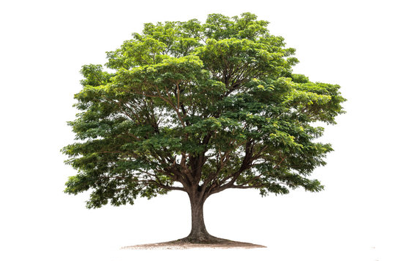

**Output:**

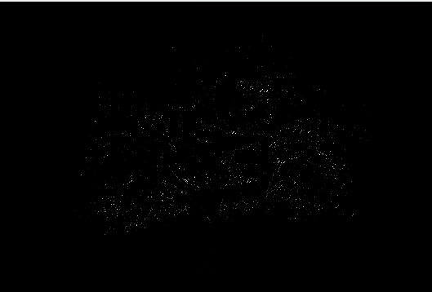

**Result:**

The python code to perform sharpening of image using Laplacian Mask with negative centre coefficient has been executed successfully.